***Concept of the database of the application***

*What data does our app manage?*

Our app manages:

* Milk Records (each time milk is collected)
* Clients (people or companies we sell to or collect from)

1. ***Client table :***

|  |  |  |
| --- | --- | --- |
| Field | Type | Description |
| ID | Integer | Client’s ID (primary key) |
| Name | String | Client’s name(required) |
| Phone | String | Client’s phone number(optional) |
| Email | String | Client’s email address(optional) |
| Address | String | Client’s address(optional) |
| Created_at | datetime | When the client was added |

***2. Milk collection table:***

|  |  |  |
| --- | --- | --- |
| Field | Type | Description |
| id | integer | Unique identifier for each record (Primary Key) |
| date | date | Date of milk collection |
| quantity | float | Amount of milk collected (liters) |
| price_per_liter | float | Price per liter (currency) |
| total_amount | float | Total price (quantity × price_per_liter) |
| client_name | string | Name of the client (optional, for reference) |
| notes | string | Any notes about the collection (optional) |
| collection_time | string | string Time of collection (optional) |
| fat | float | Fat percentage (optional) |
| protein | float | Protein percentage (optional) |
| temperature | float | Temperature at collection (optional) |
| quality_grade | string | Quality grade (Excellent, Good, Fair, Poor) |
| created_at | datetime | When the record was added |

* One client can have many milk records.
* Each milk record can be linked to a client (by name).

Here we have a class diagram that visualizes the relationship between the client and the milk record.

As we see, there is an association between them; one client can have zero or more milk records.

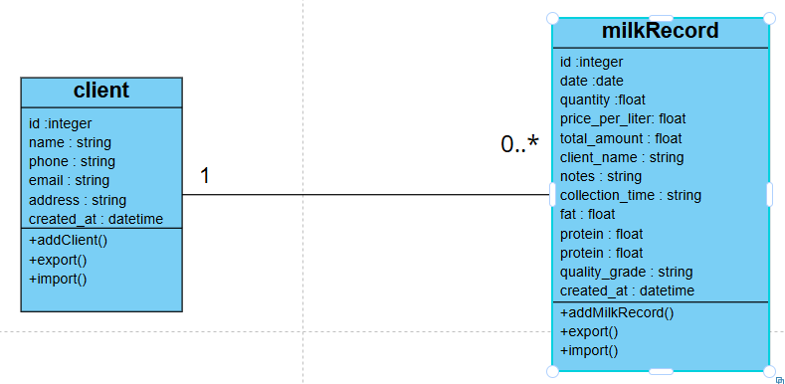

***How Is This Implemented in our App?***

* On the Web:

Data is stored in localStorage as arrays of objects (one for clients, one for milk records).

* On Mobile (SQLite):

Data is stored in two tables: clients and milk_collection.

* Export/Import:

Both tables are exported/imported as Excel sheets.

***Why This Design?***

* Simplicity:

Only two main tables, easy to understand and maintain.

* Flexibility:

Optional fields allow us to store as much or as little info as needed.

* Extensibility:

We can add more fields or tables later (e.g., payments, products).